2FA 2 factor authentication for District GIS Parakh users for all district and department level logins

Step 1: login into account through web browser :
verify on Prod: geoportal.mp.gov.in/parakhweb/
select on Department and enter your user name and password

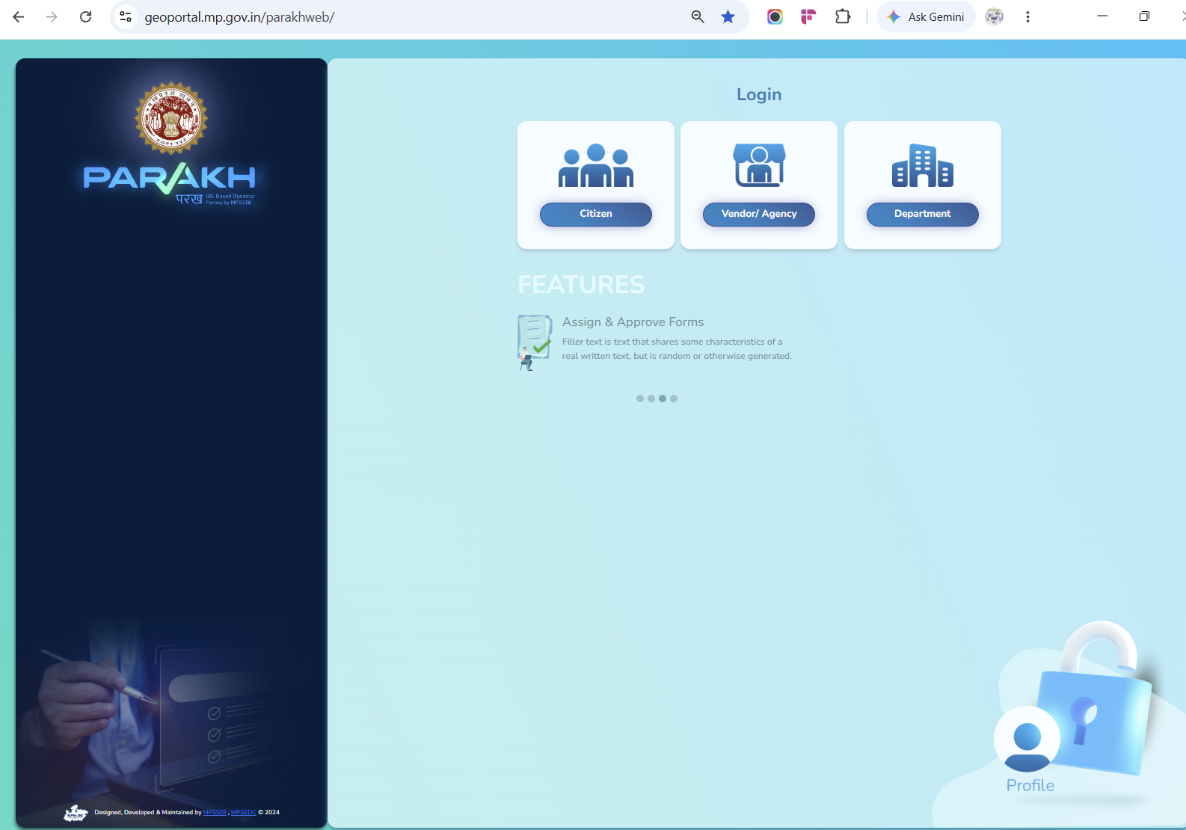
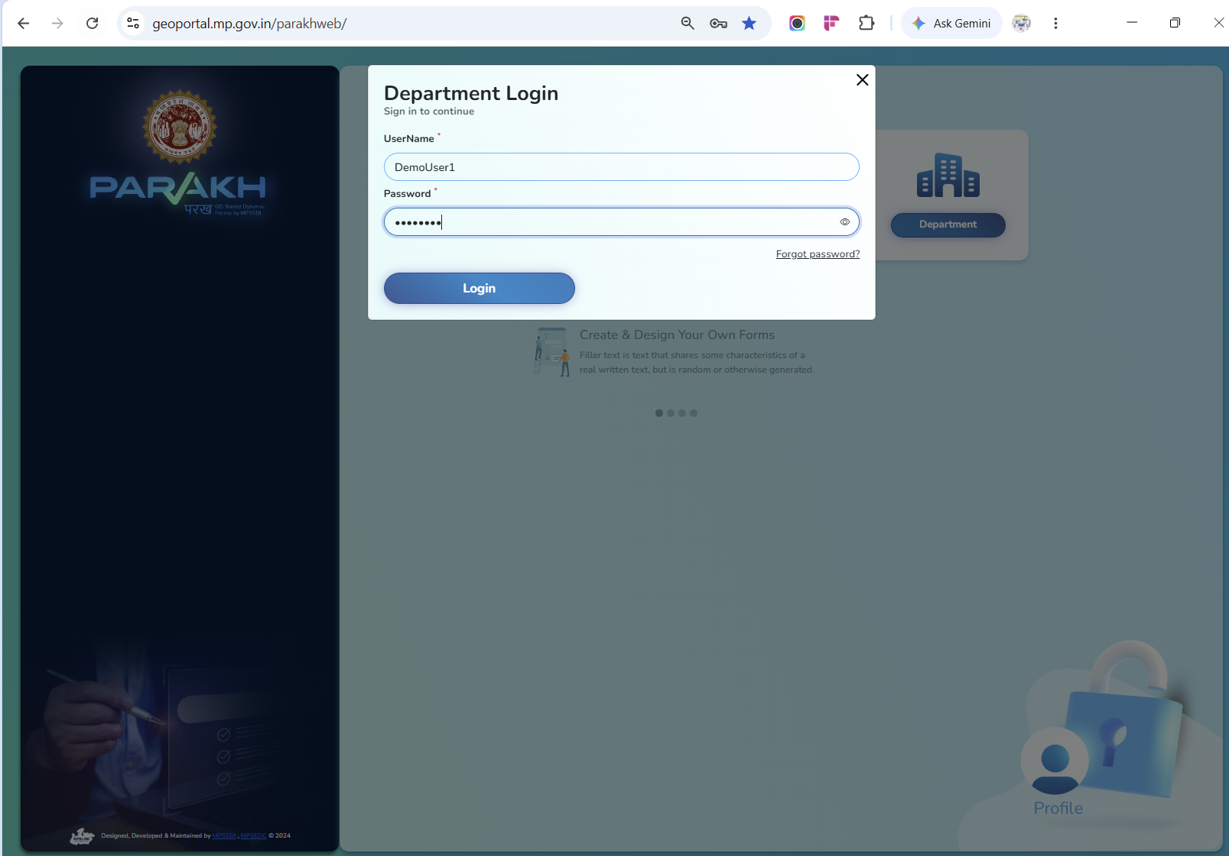
Step 2:

After login through your credentials, it will ask for verifying your mobile (contact number)
click on Ok
and fill all mandatory fields such as ----
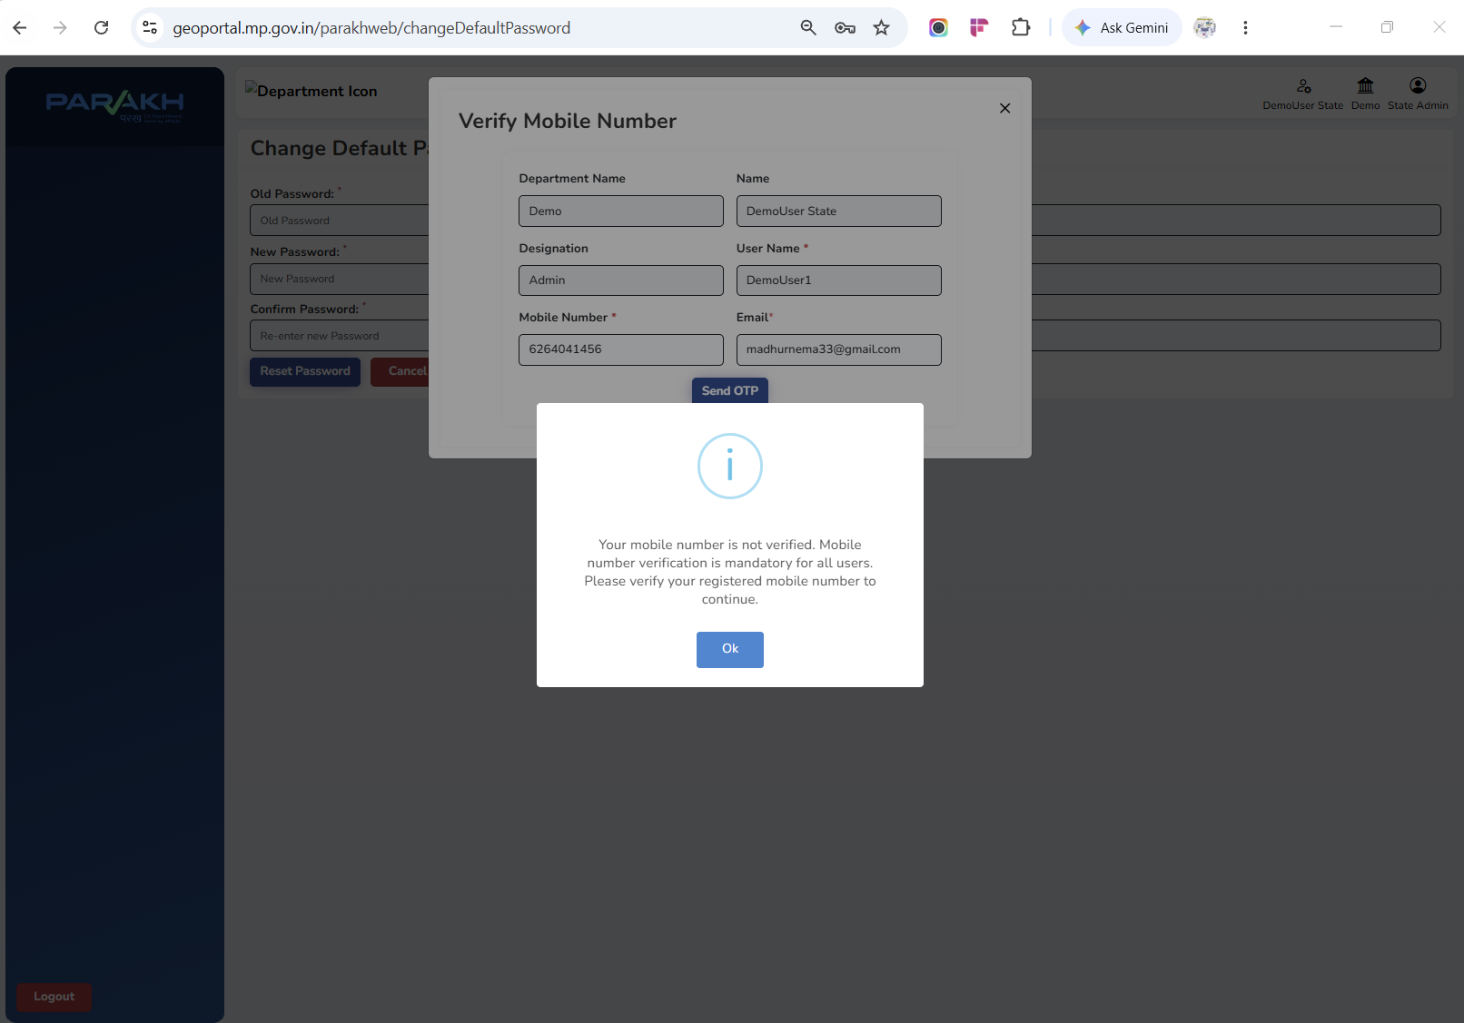
check your mobile number - it will be used for 2FA so make sure your are updating with mobile no that you will be using going forward
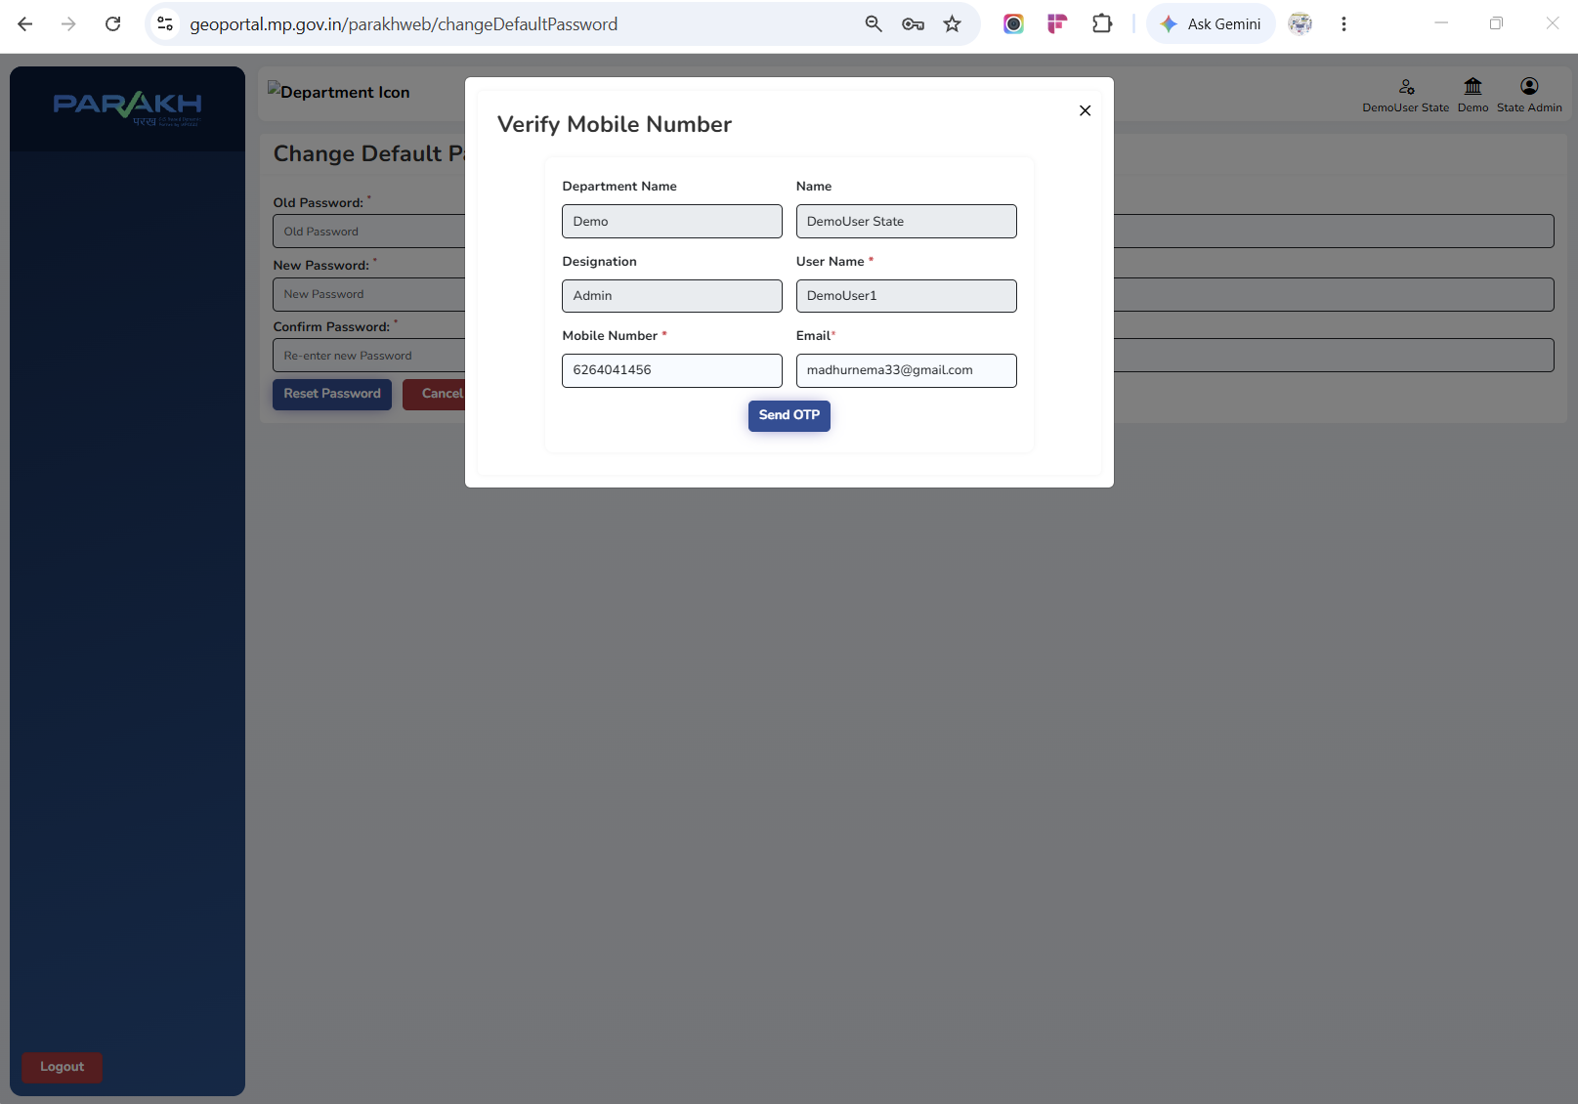

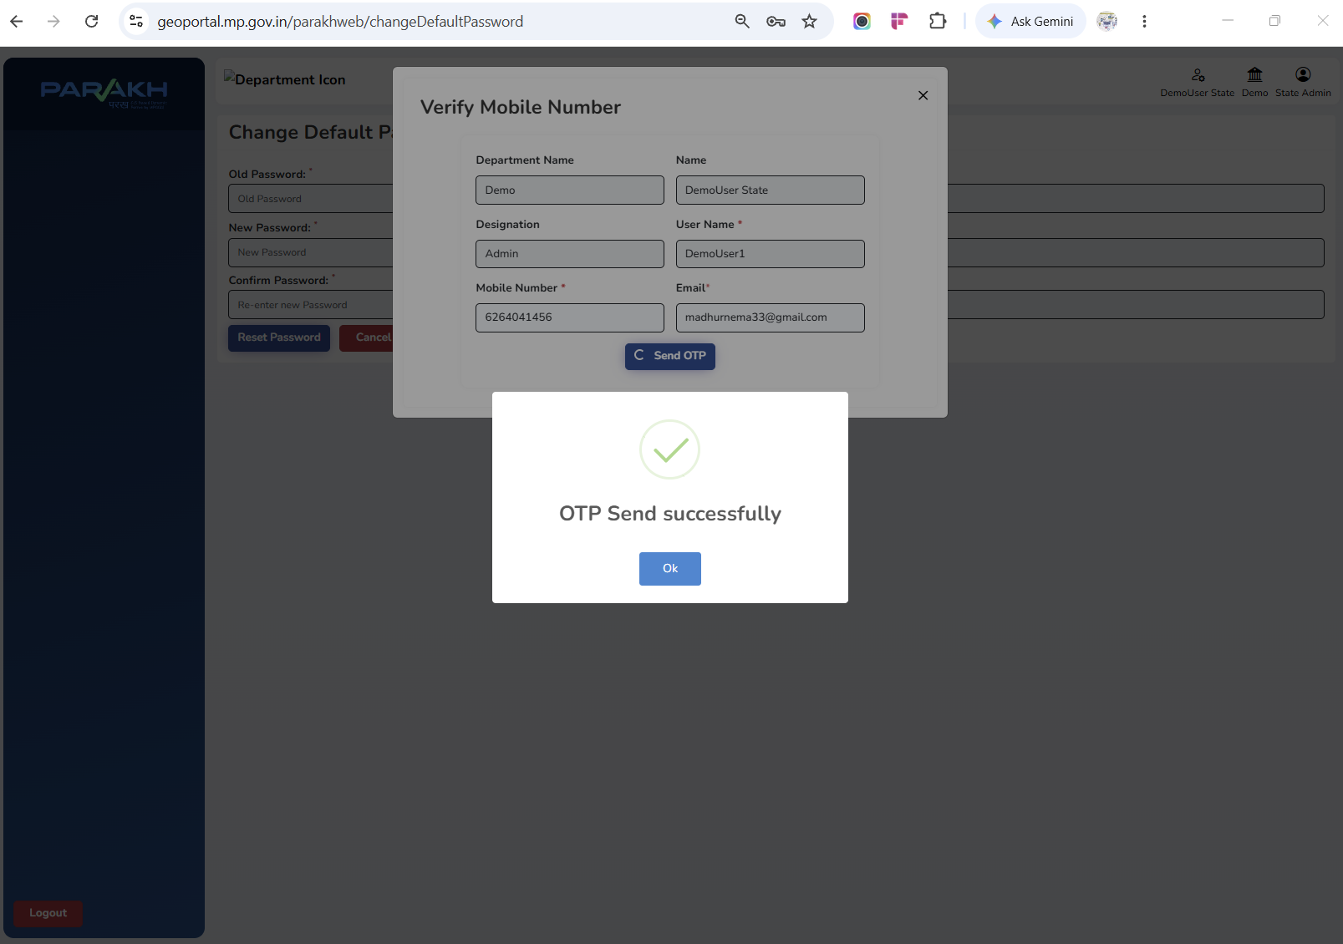

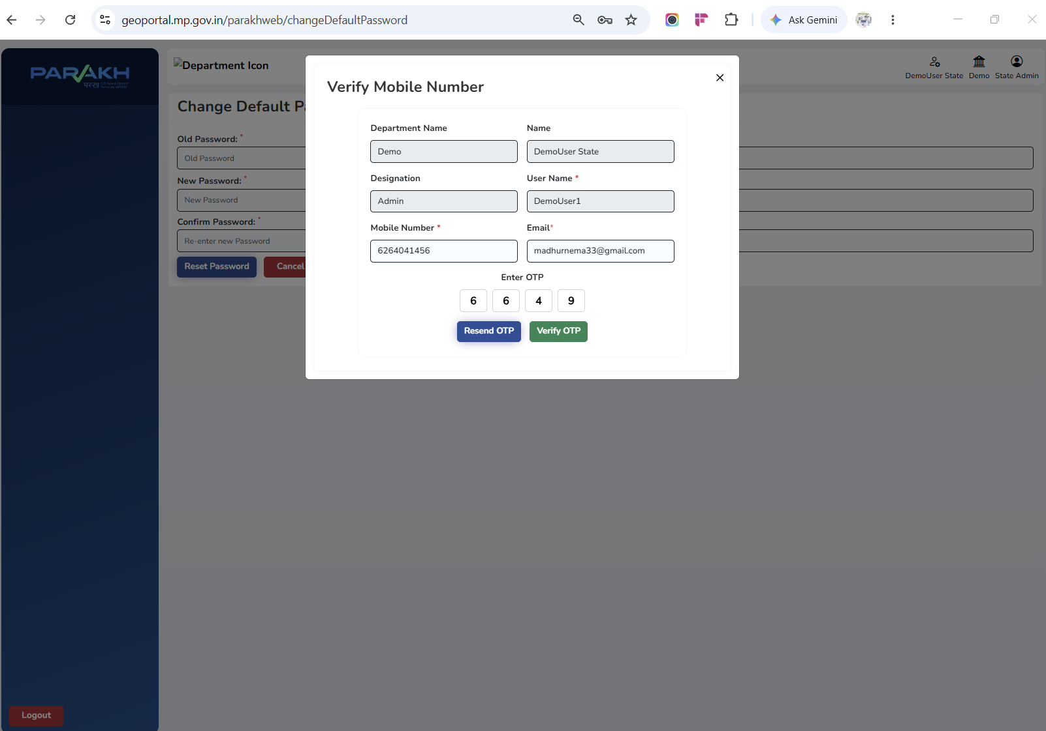
Step 3:
you will receive an OTP on your mobile number (OTP valid for next 10 minutes after that it will expire)
this is compulsory and it comes under government guidelines
and mandatory as per government d=guidelines at state level
Time line to complete this process. It should be complete next week
Step 4: once your mobile number is verified. Then after your mobile number is verified for 2 factor authentication
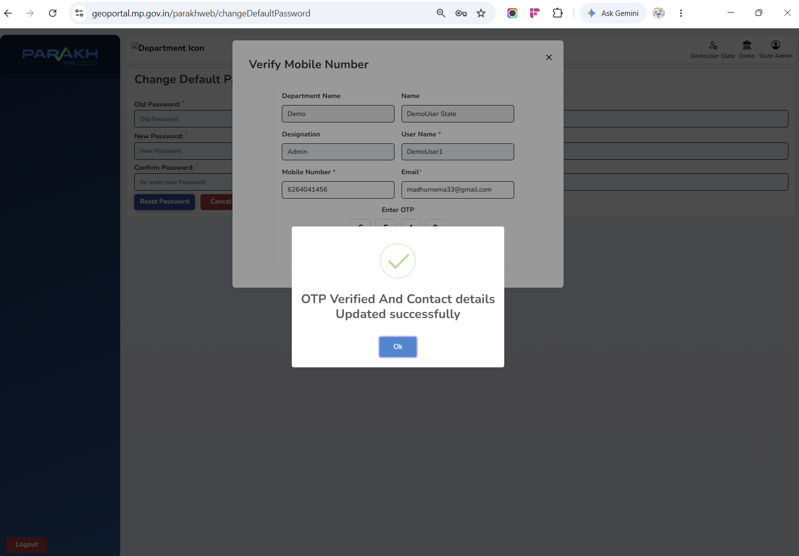
Now, 2FA is enabled for your registered mobile number.

